







Crossroads Design for

6.28.10 release

**(Premium Customer Services (PCS) 2.5)**

* **Premium Customer Services (PCS) 2.5 [PR_4292]**

Version 1.0

Issued: 08/12/2014



This material is the exclusive property of, and confidential to, Syniverse Technologies, Inc.   
Any disclosure or reproduction of this material without Syniverse’s   
express prior ACC_Rpt-WRitten consent is strictly prohibited.

The following product and service names, and the Syniverse name and logo are services, software products, service marks and/or trademarks of Syniverse Technologies, Inc.

|  |  |
| --- | --- |
| ACCESS S&E® | LAWBUST® |
| ACCESS® | PageNameSM |
| ACCESSibility® | Phone Me Anywhere Plus® |
| CCNSSM | PMA Plus® |
| CELLI® | RoamerXchange® |
| Commercial Carrier Network ServicesSM | SmartChallenge® |
| CrossroadsSM | SOLUTIONS® |
| EDTSM | Solutions Without Limits® |
| Electronic Data TransportSM | S.T.A.R.S. STREAMLINERTM |
| Encrypt-A-Key® | S.T.A.R.S. STREAMLINER Terminal Access Reporting System® |
| Fleet-On-TrackSM | STARS Special Thanks Awards for Remarkable Service® (logo) |
| Follow Me Roaming Plus® | STARS® |
| FraudInterceptor® | STARS® (logo) |
| FraudManager® | StatChek® |
| Fraud Resource CenterSM | STREAMLINER® |
| FraudX® | TransAction Manager® |
| GSM SS7 Transport® | Syniverse ConnectionsSM |
| InForum | Syniverse DataNetSM |
| inpackSM | UniRoamSM |
| INPort® | Visibility® |
| INPositionSM | WIN4SM** |
| LATALinkSM |  |

Netscape and Netscape Communicator are registered trademarks of Netscape   
Communications Corporation.  
Microsoft and Windows are registered trademarks of Microsoft Corporation.  
Office and BackOffice are trademarks of Microsoft Corporation.

Used by Permission.

As used herein, ® denotes registration in the United States.

© Copyright 2008 Syniverse Technologies, Inc.  
All rights reserved under U.S. and International laws.[1]‡

Revision History

|  |  |  |  |
| --- | --- | --- | --- |
| Version | Date | Release Reason - Description of Changes | Author |
| 1.0 | 08/12/2014 | Initial Version | Marvin Li |

Table of Contents

1 Introduction 5

1.1 Purpose 5

1.2 Definitions, Acronyms, and Abbreviations 5

1.3 Correction and Revisions 5

2 Software Design 6

2.1 High Level Design Details – Permission Level 6

For Both Syniverse and Non Syniverse Company 6

2.2 Detailed Changes 7

2.3 DNS entries 10

2.4 Grant Perms 10

3 Requirements Tracing Matrix 11

# Introduction

## Purpose

The purpose of this document is to explain the design of VisProactive Diameter

## Definitions, Acronyms, and Abbreviations

Table ; Terminology

| Acronyms and Abbreviations | Description |
| --- | --- |
| GUI | Graphical User Interface |
| CTP | Central Tables Provisioning |
| uid | unique identifier |
| ou | organizational unit (LDAP) |
| MDR | Mobile Data Roaming |

## Correction and Revisions

Please direct comments or suggestions for modification, preferably via email, to:

**Marvin Li**

**086-025-88037115**

[marvin.li@syniverse.com](mailto:marvin.li@syniverse.com)

# Software Design

## High Level Design Details – Permission Level

### Syniverse Company

No new company permission is added. Nothing needs to be verified in company permission level

### Syniverse User

For a Syniverse User, We initially grant user permission **Service Level View** to the user who has already been grant user permission **Premium Customer Services GUI** initially.

So, please initially verify that user permission **Service Level View** is checked as long as user permission **Premium Customer Services GUI** is checked. However, please understand that

1. These two user permissions actually have nothing to do with each other, after the inital grant, they do not affect each other
2. User permission **Service Level View** will bring the link **Monitor my Subscribers** link, and user permission **Premium Customer Services GUI** also brings this link, which is to say, **Monitor my Subscribers** link will be shown as long as any one of the two user permissions is checked

User permission **Service Level View** user will bring **Monitor my Subscribers** link, and user permission **Analyzer PCS Reporting** user will bring **Analyzer PCS Reporting** link

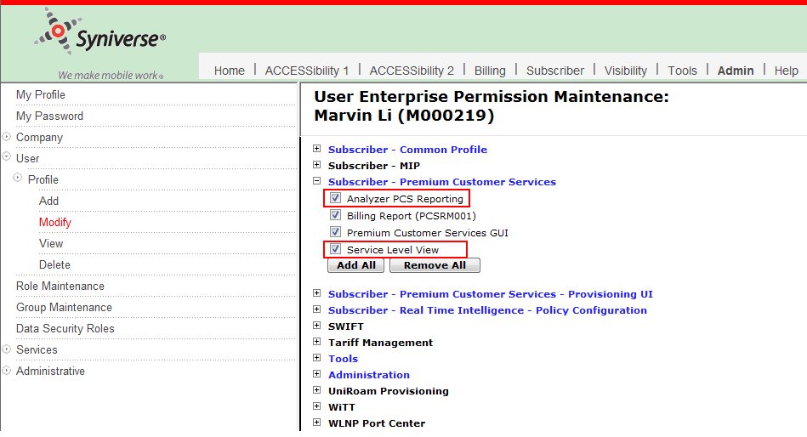

This user should see these links under **Subscriber** tab. Logically all the links should be clicked and verified if they are showing properly or not.

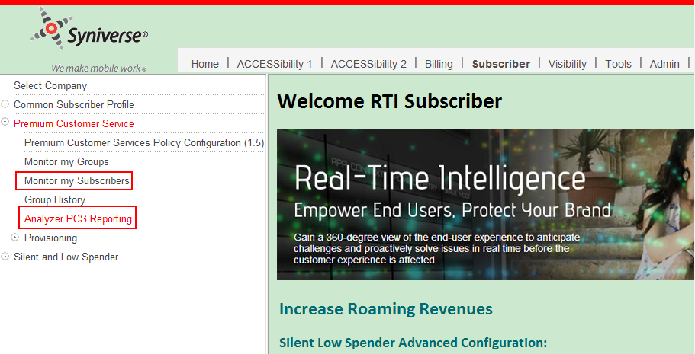

### Customer Test Company

No new company permission is added. Nothing needs to be verified in company permission level

### Customer Test Company User

Assign the two user permissions to this company User.

User permission **Service Level View** user will bring **Monitor my Subscribers** link, and user permission **Analyzer PCS Reporting** user will bring **Analyzer PCS Reporting** link

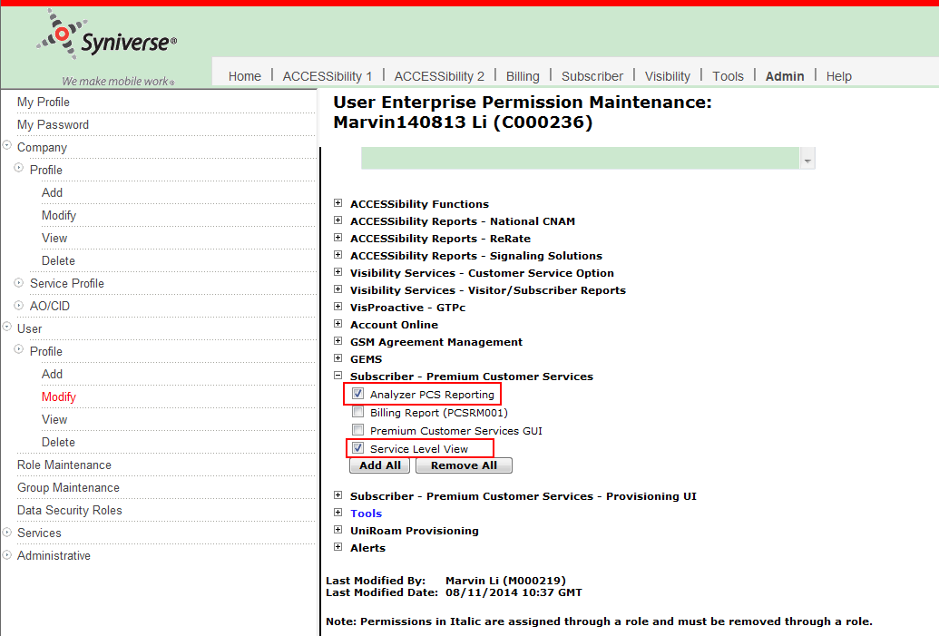

This user should see these links under **Subscriber** tab. Logically all the links should be clicked and verified if they are showing properly or not.

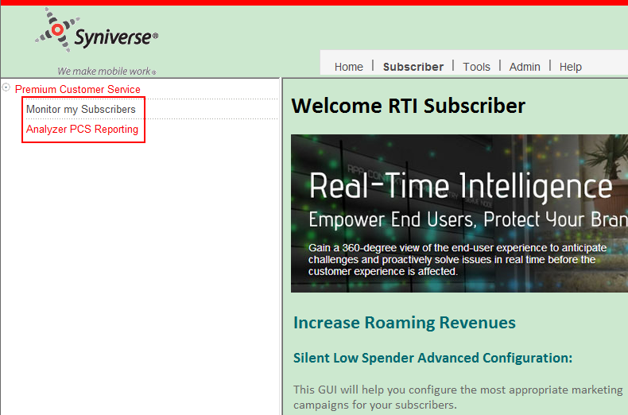

## Detailed Changes

**New Implied User Permission:**

**Permission Id:** Implied_PCS_GUI_userP

**Presentation Label:** Implied Premium Customer Services GUI

A new Implied Permission resource will be added to the RESOURC table with RSRC_ID: Implied_PCS_GUI_userP

This resource will link to a new presentation entry that will be added to the PRESENTATION table

- The PRSENTATION entry’s Implied_PCS_GUI_userP_prsn

- The PRSENTATION entry will have label of " Implied Premium Customer Services GUI"

The presentation order will be: 0000

A Product relationship to the product resource, SUBSCRIBER, will be added to the RSRC_TO_RSRC_REL table for this resource so that the Subscriber tab will be displayed for any users that are assigned this permission

An entry will also be added to the LDAP for this permission under ou=PermissionCode, o=Crossroads with attributes as described above

**Change User Permission:** PCS_GUI

**Permission Id:** PCS_GUI

**Presentation Label:** Premium Customer Services GUI

The presentation order will be changed from 0010 to: 0020

An Implied relationships to the permission resource, Implied_PCS_GUI_userP, will be added to the RSRC_TO_RSRC_REL table for this resource

**New User Permission:**

**Permission Id:** PCS_Analyzer_PCS_Reporting_userP

**Presentation Label:** Analyzer PCS Reporting

A new Permission resource will be added to the RESOURC table with RSRC_ID: PCS_Analyzer_PCS_Reporting_userP

This resource will link to a new presentation entry that will be added to the PRESENTATION table

- The PRSENTATION entry’s PCS_Analyzer_PCS_Reporting_userP_prsn

- The PRSENTATION entry will have label of " Analyzer PCS Reporting "

A Copermission relationship the new permission resource, PCS_GUI_Co, will be added to the RSRC_TO_RSRC_REL table for this resource

The presentation order will be: 0010

A Product relationship to the product resource, SUBSCRIBER, will be added to the RSRC_TO_RSRC_REL table for this resource so that the Visibility tab will be displayed for any users that are assigned this permission

A PermissionGroup relationship to the new permissionGroup resource, Subscriber_PCS_Group, will be added to the RSRC_TO_RSRC_REL table for this resource

A Implied relationships to the permission resource, Implied_PCS_GUI_userP, will be added to the RSRC_TO_RSRC_REL table for this resource

This Permission will have Presentation label tag : ANALYZER_PCS_REPORTING

An entry will also be added to the LDAP for this permission under ou=PermissionCode, o=Crossroads with attributes as described above

**New User Permission:**

**Permission Id:** PCS_Service_Level_View_userP

**Presentation Label:** Analyzer PCS Reporting

A new Permission resource will be added to the RESOURC table with RSRC_ID: PCS_Service_Level_View_userP

This resource will link to a new presentation entry that will be added to the PRESENTATION table

- The PRSENTATION entry’s PCS_Service_Level_View_userP_prsn

- The PRSENTATION entry will have label of "Service Level View"

A Copermission relationship the new permission resource, PCS_GUI_Co, will be added to the RSRC_TO_RSRC_REL table for this resource

The presentation order will be: 0010

A Product relationship to the product resource, SUBSCRIBER, will be added to the RSRC_TO_RSRC_REL table for this resource so that the Visibility tab will be displayed for any users that are assigned this permission

A PermissionGroup relationship to the new permissionGroup resource, Subscriber_PCS_Group, will be added to the RSRC_TO_RSRC_REL table for this resource

A Implied relationships to the permission resource, Implied_PCS_GUI_userP, will be added to the RSRC_TO_RSRC_REL table for this resource

This Permission will have Presentation label tag : SERVICE_LEVEL_VIEW

An entry will also be added to the LDAP for this permission under ou=PermissionCode, o=Crossroads with attributes as described above

**New Menu Item:**

**Id:** PCS_Analyzer_PCS_Reporting_menuitem_prsn

**Presentation Label:** Analyzer PCS Reporting

A new Menu Item resource will be added to the RESOURC table with RSRC_ID PCS_Analyzer_PCS_Reporting_menuitem

This resource will link to a new presentation entry that will be added to the PRESENTATION table

- The PRSENTATION entry’s PCS_Analyzer_PCS_Reporting_menuitem_prsn

- The PRSENTATION entry will have label of " Analyzer PCS Reporting "

This menu item is visible on the crossroads application when the logged in user has the **Permission Id:** PCS_Analyzer_PCS_Reporting_userP

This menu item is placed under the menu group id: Premium_Customer_Service_Menu

This menu item will have have **url** value: https://${PCS}/pcs/faces/grouphistory

This menu item will have have **frameid** value: parent.ContentFrame

This Permission will have Presentation label tag : ANALYZER_PCS_REPORTING

An entry will also be added to the LDAP for this menu under ou=PresentationObjects, o=Crossroads with attributes as described above

## DNS entries

These are the new DNS entries required

* VISPRO_DIAMETER=vis-diameter-portal-dev-alt.syniverse.com [6.xx DEV]
* VISPRO_DIAMETER=vis-diameter-portal-test-alt.syniverse.com [6.xx TEST]
* VISPRO_DIAMETER=vis-diameter.syniverse.com [production]
* VISPRO_DIAMETER=vis-diameter-portal-dev.syniverse.com [7.xx DEV]
* VISPRO_DIAMETER=vis-diameter-portal-test.syniverse.com [7.xx TEST]

## Grant Perms

No grant Permissions

# Requirements Tracing Matrix

| Traceability Map  Premium Customer Services (PCS) 2.5  [**http://central.syniverse.com/sites/NET/BIAREQUIREMENTS/Premium%20Customer%20Service%20PCS%2025/Forms/AllItems.aspx?RootFolder=%2Fsites%2FNET%2FBIAREQUIREMENTS%2FPremium%20Customer%20Service%20PCS%2025%2FRequirements&FolderCTID=0x012000723C72052E4ECE4CB661FBDD691B0581&View=%7b14A5549A-CDFC-4E89-9891-3DCD66ED98D6%7d**](http://central.syniverse.com/sites/NET/BIAREQUIREMENTS/Premium%20Customer%20Service%20PCS%2025/Forms/AllItems.aspx?RootFolder=%2Fsites%2FNET%2FBIAREQUIREMENTS%2FPremium%20Customer%20Service%20PCS%2025%2FRequirements&FolderCTID=0x012000723C72052E4ECE4CB661FBDD691B0581&View=%7b14A5549A-CDFC-4E89-9891-3DCD66ED98D6%7d) | | |
| --- | --- | --- |
| For <Asset or Team> | | |
| High Level Design | Detail Level Design | System Test Plan |
| <Link to HLD> | <Link to DLD> | <Link to System Test Plan> |

| Requirement  # | Requirement title | Asset/Team | HLD  # | DLD  # | Test  # | Comment |
| --- | --- | --- | --- | --- | --- | --- |
| 3 | FEATURE REQUIREMENTS |  |  |  |  |  |
| 3.1 | RTI |  |  |  |  |  |
| 3.1.1 | RTI Receives Additional Data Feeds |  |  |  |  |  |
| 3.1.2 | RTI Tracks QoE KPI Data for Monitored IMSIs |  |  |  |  |  |
| 3.1.2.1 | Data QoE Parameters |  |  |  |  |  |
| 3.1.2.1.1 | RTI shall have the ability to track the following data QoE parameters for monitored IMSIs for 2G, 3G, 4G, and an average for all networks: |  |  |  |  |  |
| 3.1.2.1.2 | RTI shall have the ability to use a weighted algorithm to compute the average bandwidths for aggregate intervals (30 min, 1 hour, 24 hours, 7 days). |  |  |  |  |  |
| 3.1.2.2 | Aggregate QoE Metrics |  |  |  |  |  |
| 3.1.2.3 | Provision QoE KPI Threshold Values |  |  |  |  |  |
| 3.1.2.4 | Determine Status for Data QoE |  |  |  |  |  |
| 3.1.2.4.1 | RTI shall have the ability to create a rules matrix where by the user can select any of the 5 KPIs in any combination to calculate the overall data quality status based on the 30 minute bucket. |  |  |  |  |  |
| 3.1.3 | Updating Templates |  |  |  |  |  |
| 3.2 | PCS GUI |  |  |  |  |  |
| 3.2.1 | Monitor My Subscriber |  |  |  |  |  |
| 3.2.1.1 | Network Level View |  |  |  |  |  |
| 3.2.1.2 | Service Level View |  |  |  |  |  |
| 3.2.1.2.1 | Service Level View Search Criteria |  |  |  |  |  |
| 3.2.1.2.1.1 | Service Level View Data |  |  |  |  |  |
| 3.2.1.2.1.2 | Display Most Recent Session Attempt |  |  |  |  |  |
| 3.2.1.2.1.3 | Move IMSI to Working Area |  |  |  |  |  |
| 3.2.1.2.1.4 | Display Summary Statistics |  |  |  |  |  |
| 3.2.1.3 | Service Level Summary View Information |  |  |  |  |  |
| 3.2.1.3.1 | Last Completed Session |  |  |  |  |  |
| 3.2.1.3.2 | 30 min, 1 hr, 24 hr, 7 days |  |  |  |  |  |
| 3.2.1.4 | Existing Actions Tab |  |  |  |  |  |
| 3.2.1.4.1 | If a user only has permission for Network level view then on the actions tab the user will only see details for Network Level. |  |  |  |  |  |
| 3.2.1.4.2 | If a user has permission for Service level view then on the actions tab the user will see both Network and Service level view. |  |  |  |  |  |
| 3.2.2 | Monitor My Groups |  |  |  |  |  |
| 3.2.2.1 | New Columns for Service Level |  |  |  |  |  |
| 3.2.2.1.1 | Link to Service Level View |  |  |  |  |  |
| 3.2.3 | Escalation Alerts |  |  |  |  |  |
| 3.2.3.1 | Add to Working Area |  |  |  |  |  |
| 3.2.3.2 | Dismiss Alert |  |  |  |  |  |
| 3.3 | SERVICE LEVEL DETAIL VIEW INFORMATION |  |  |  |  |  |
| 3.3.1 | Bandwidth Reports |  |  |  |  |  |
| 3.3.1.1 | Filter By Criteria for Bandwidth Report |  |  |  |  |  |
| 3.3.1.2 | Display Trending Information for Bandwidth Report |  |  |  |  |  |
| 3.3.1.3 | Display Data in Table for Bandwidth Report |  |  |  |  |  |
| 3.3.2 | Data Session Context Report |  |  |  |  |  |
| 3.3.2.1 | Filter By Criteria for Data Session Context Report |  |  |  |  |  |
| 3.3.2.2 | Display Trending Information for Data Session Context Report |  |  |  |  |  |
| 3.3.2.3 | Display Data in Table for Data Session Context Report |  |  |  |  |  |
| 3.3.3 | Data Session Activation Time Report |  |  |  |  |  |
| 3.3.3.1 | Filter By Criteria for Data Session Activation Time Report |  |  |  |  |  |
| 3.3.3.2 | Display Trending Information for Data Session Activation Time Report |  |  |  |  |  |
| 3.3.3.3 | Display Data in Table for Data Session Activation Time Report |  |  |  |  |  |
| 3.3.4 | Reports Based on Group(s) |  |  |  |  |  |
| 3.4 | ENTERPRISE REPORTING |  |  |  |  |  |
| 3.4.1 | Adhoc Reports by Subject Area |  |  |  |  |  |
| 3.4.1.1 | Group Action and Subscriber Roaming History |  |  |  |  |  |
| 3.4.1.1.1 | Group Action History Subject Area Attributes |  |  |  |  |  |
| 3.4.1.1.2 | Subscriber Roaming History Subject Area Attributes |  |  |  |  |  |
| 3.5 | PCS PROVISIONING GUI |  |  |  |  |  |
| 3.5.1 | Multiple Template Policies per Group |  |  |  |  |  |
| 3.5.1.1 | Provision Templates |  |  |  |  |  |
| 3.5.1.1.1 | Adding/Using Templates |  |  |  |  |  |
| 3.5.1.1.2 | Template Policy Information |  |  |  |  |  |
| 3.5.1.1.2.1 | Notifications Name |  |  |  |  |  |
| 3.5.1.1.3 | Deleted Templates |  |  |  |  |  |
| 3.5.1.1.4 | Display Delete Confirmation Message |  |  |  |  |  |
| 3.6 | RULES ENGINE |  |  |  |  |  |
| 3.6.1 | Trigger Notifications |  |  |  |  |  |
| 3.6.1.1 | Trigger an email Notification when there are more than XX consecutive Data Session Create failures. The email notification should contain the following information: |  |  |  |  |  |
| 3.6.1.2 | Trigger an email Notification when the Session failure percentage in the last 30 minutes is RED OR Average B/W in the last 30 minutes is RED OR Session Activation time in the last 30 minutes is RED. The email notifications should contain the following information: |  |  |  |  |  |
| 3.6.1.3 | Trigger an email Notification when the Session failure percentage in the last 30 minutes is RED OR Average B/W for APN Node XXX in the last 30 minutes is RED OR Session Activation time in the last 30 minutes is RED. The email notifications should contain the following information: |  |  |  |  |  |
| 3.6.1.4 | Trigger an email Notification when the overall Data QOE status based on the last 30 minutes interval is RED. The email notifications should contain the following information: |  |  |  |  |  |
| 3.6.1.5 | Trigger an email Notification when the last completed session Average B/W for APN Node XXX and Network Type equal to XX is RED OR Average B/W for the last session for APN Node XXX and Network Type equal to YY is RED. The email notifications should contain the following information: |  |  |  |  |  |
| 3.6.1.6 | Trigger an email Notification if the most recent session attempt has a failed. The email notifications should contain the following information: |  |  |  |  |  |
| 3.6.2 | Rules Template Attributes |  |  |  |  |  |
| 3.6.3 | Suppression of Notifications |  |  |  |  |  |
| 3.6.4 | Group Status Notification |  |  |  |  |  |
| 3.6.5 | Logging, Reporting, and Audits |  |  |  |  |  |
| 3.7 | BILLLING |  |  |  |  |  |
| 3.8 | CROSSROADS |  |  |  |  |  |
| 3.8.1 | Left Menu Item |  |  |  |  |  |
| 3.8.2 | User Level Permissions |  |  |  |  |  |

1.